Bunny Cart Performance Testing

**Test Plan:**

**1)Average Time Response for Home Page is 2322**

**2) Duration assertion failed due to response took long time and duration time should be greater than 210000**

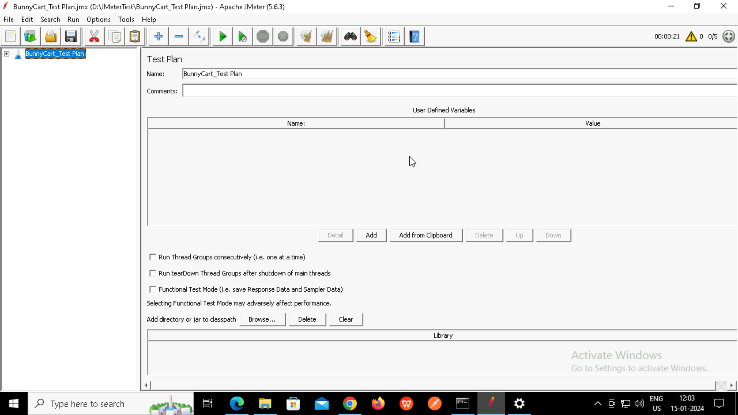

**Home Page HTTP Request Sampler:**

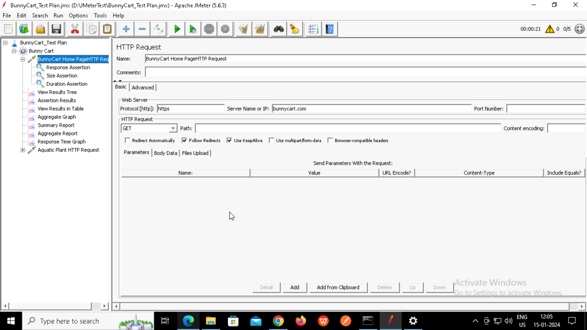

**Response Assertion:**

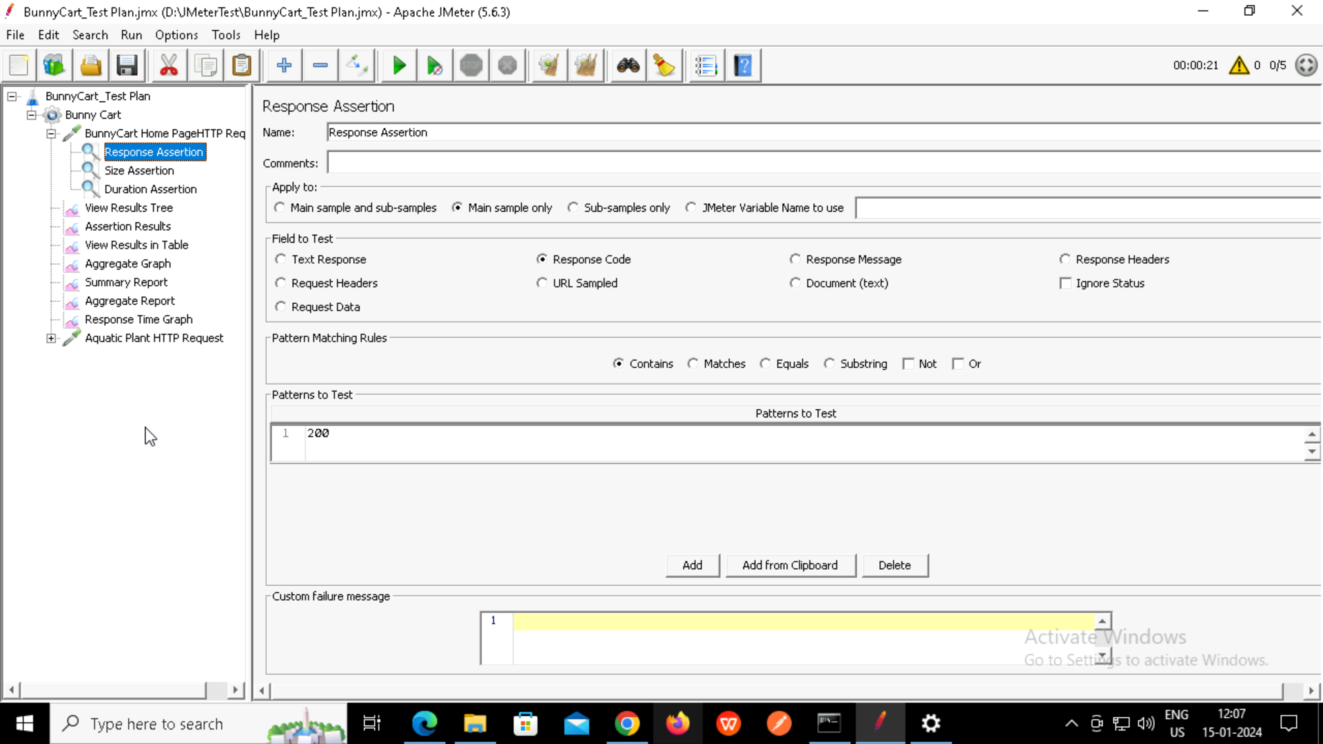

**Size Assertion:**

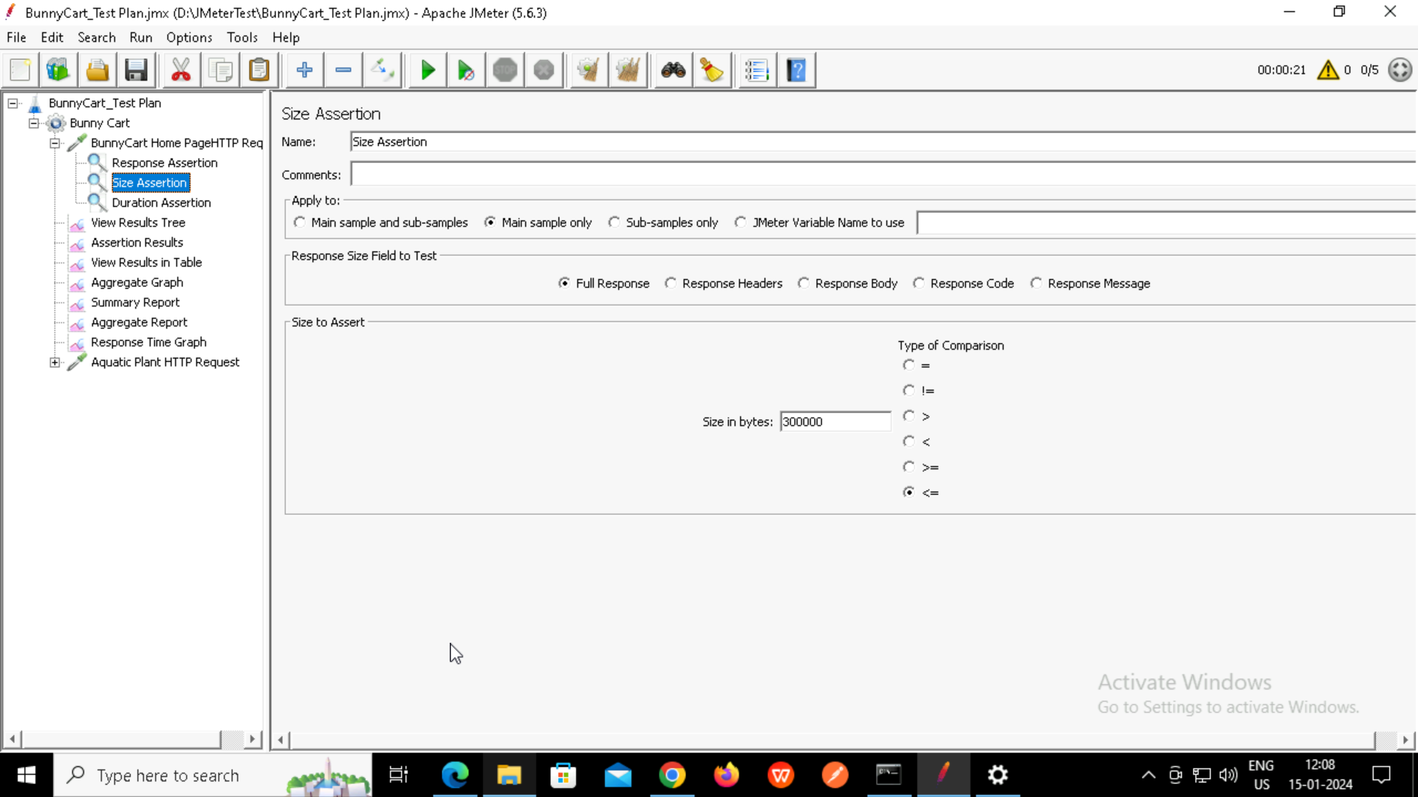

**Duration Assertion:**

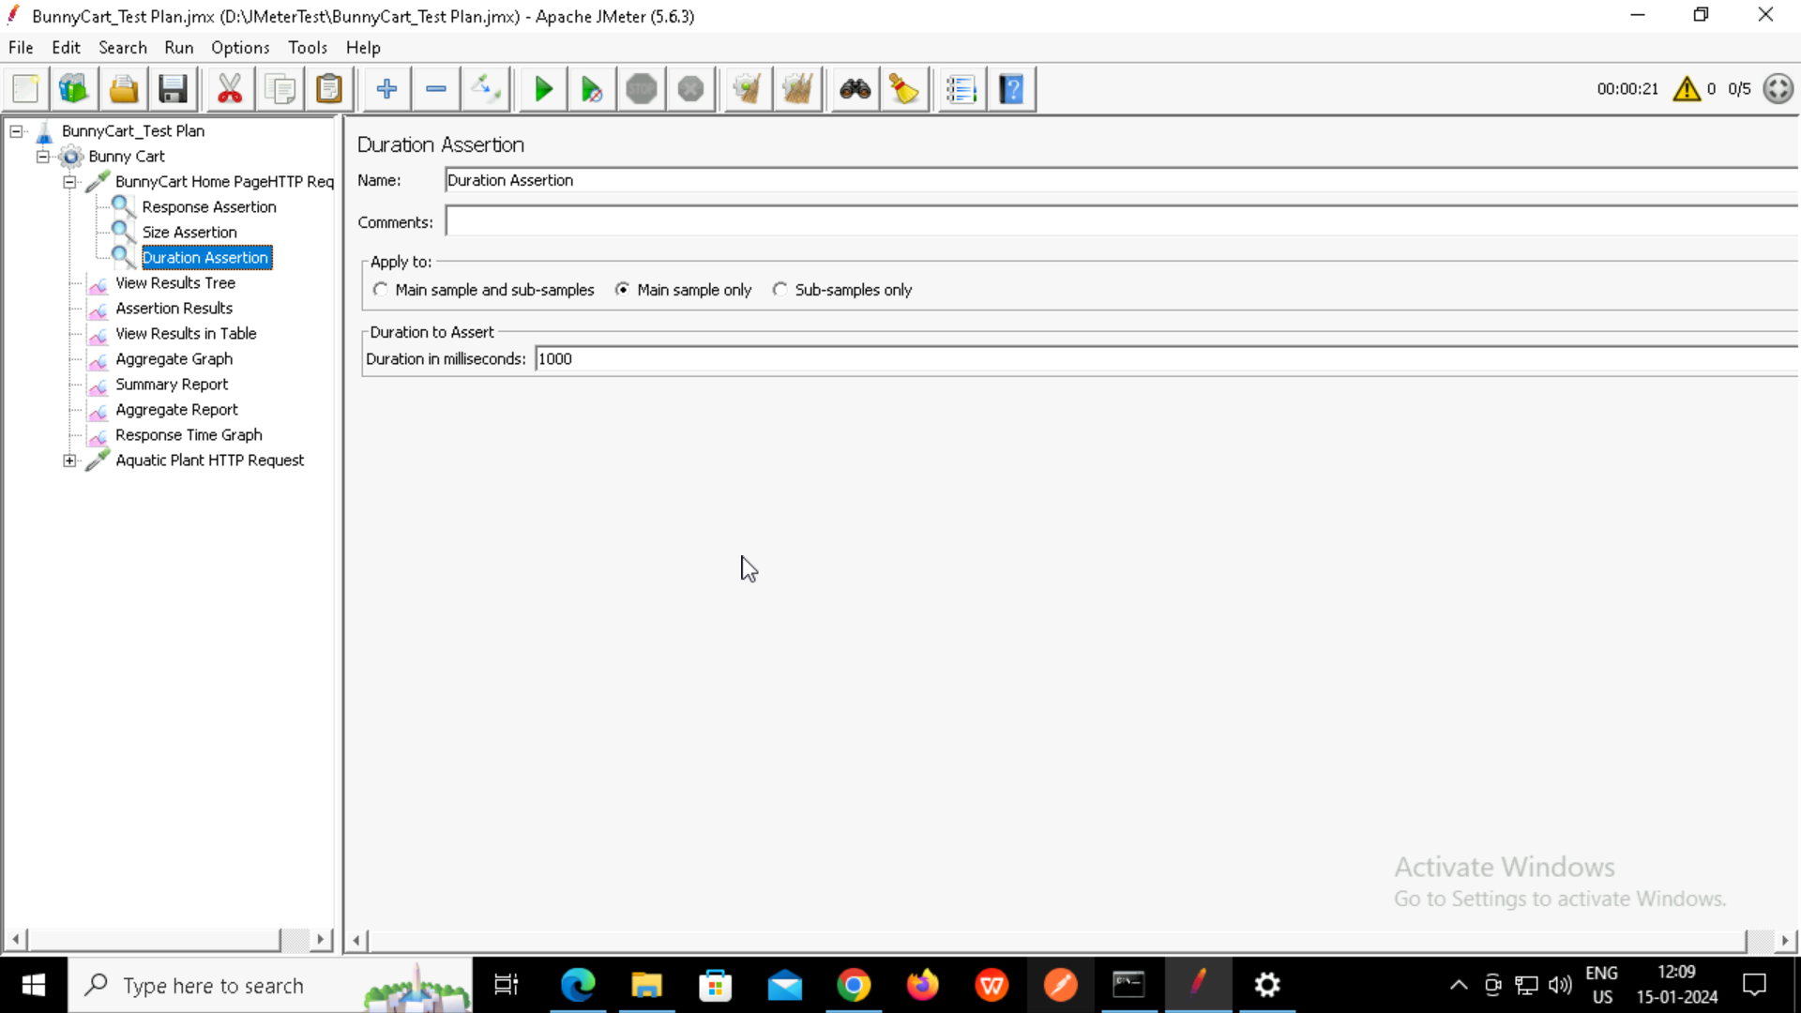

**View Result Tree:**

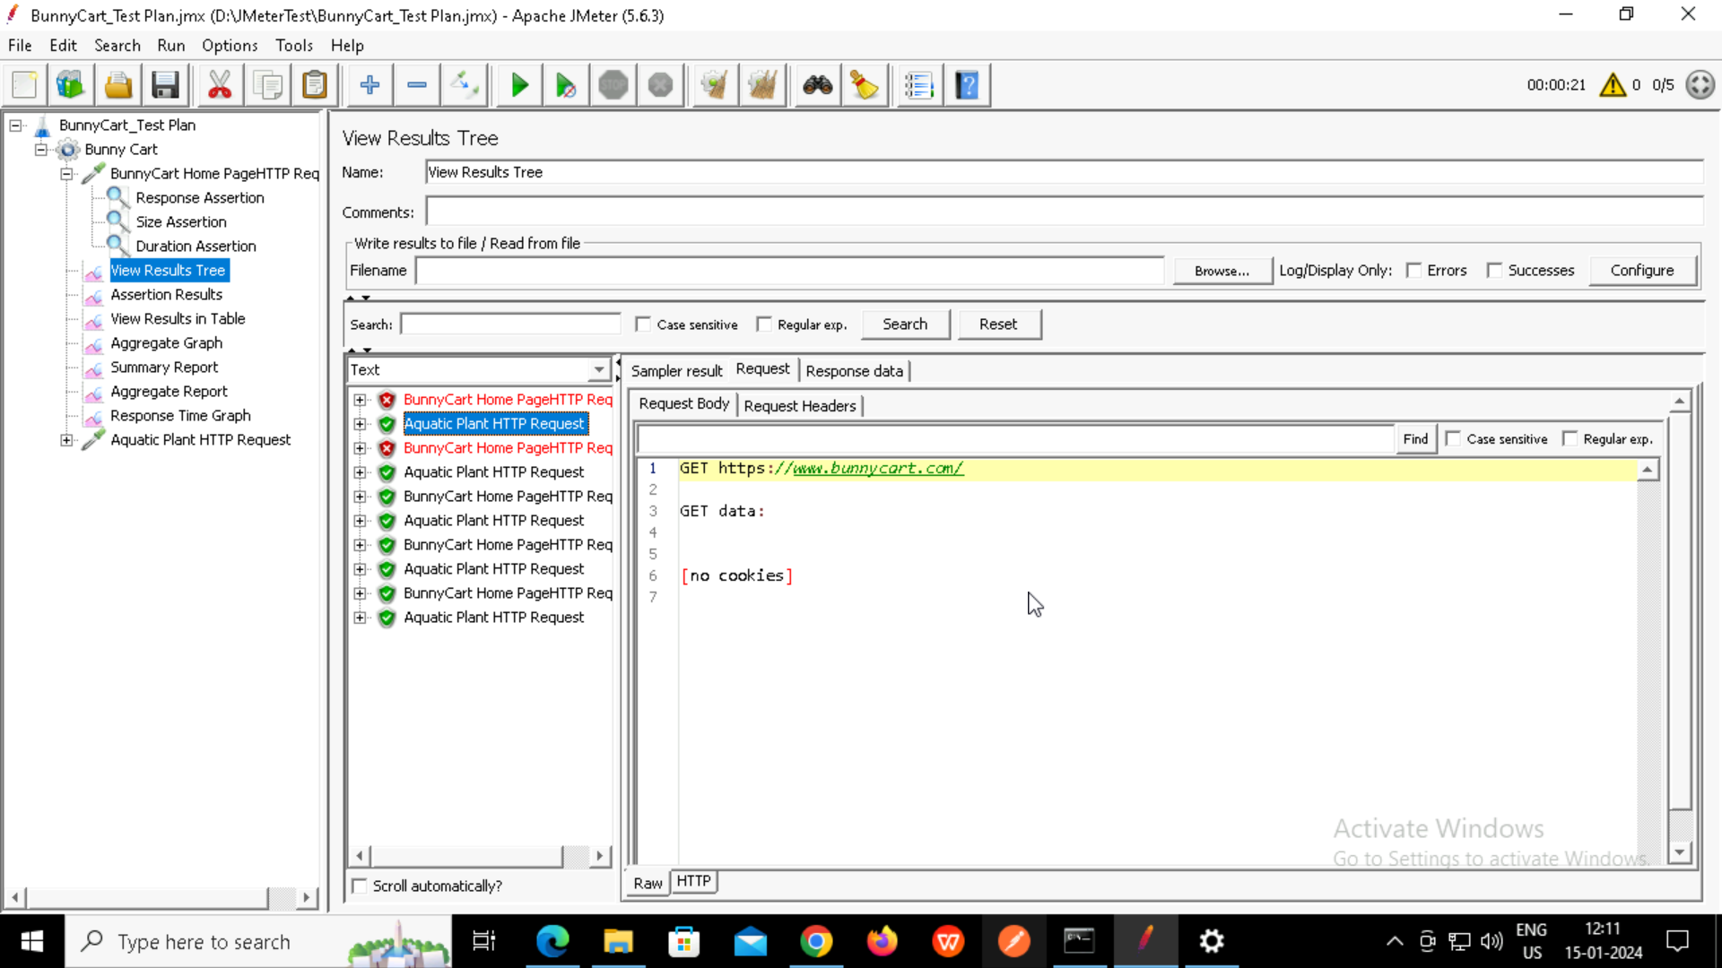

**Assertion Results:**

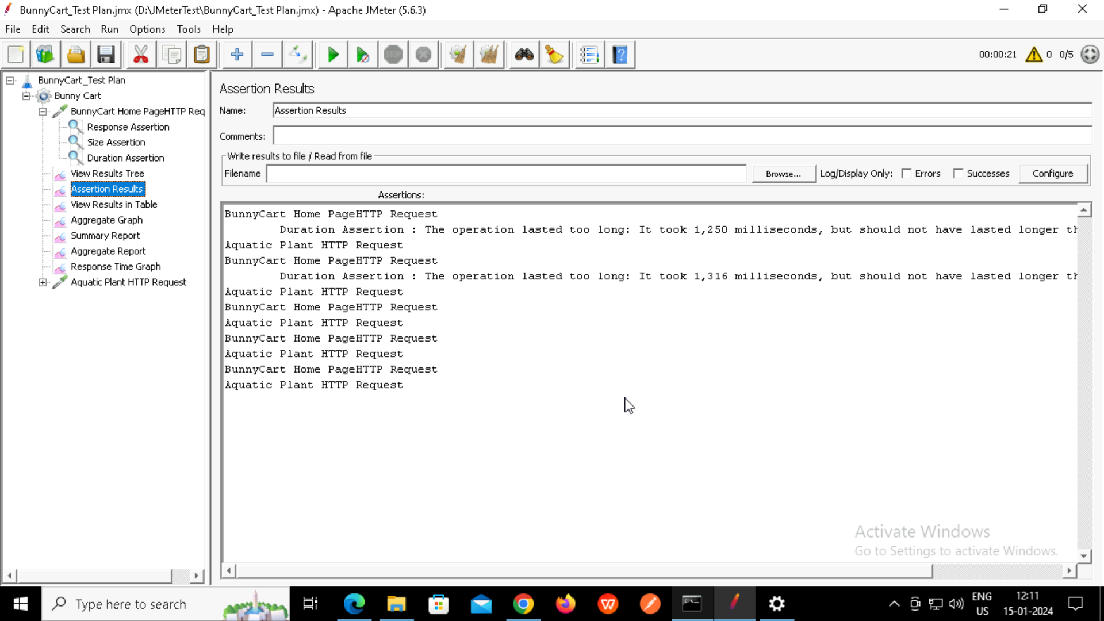

**View Results in Table:**

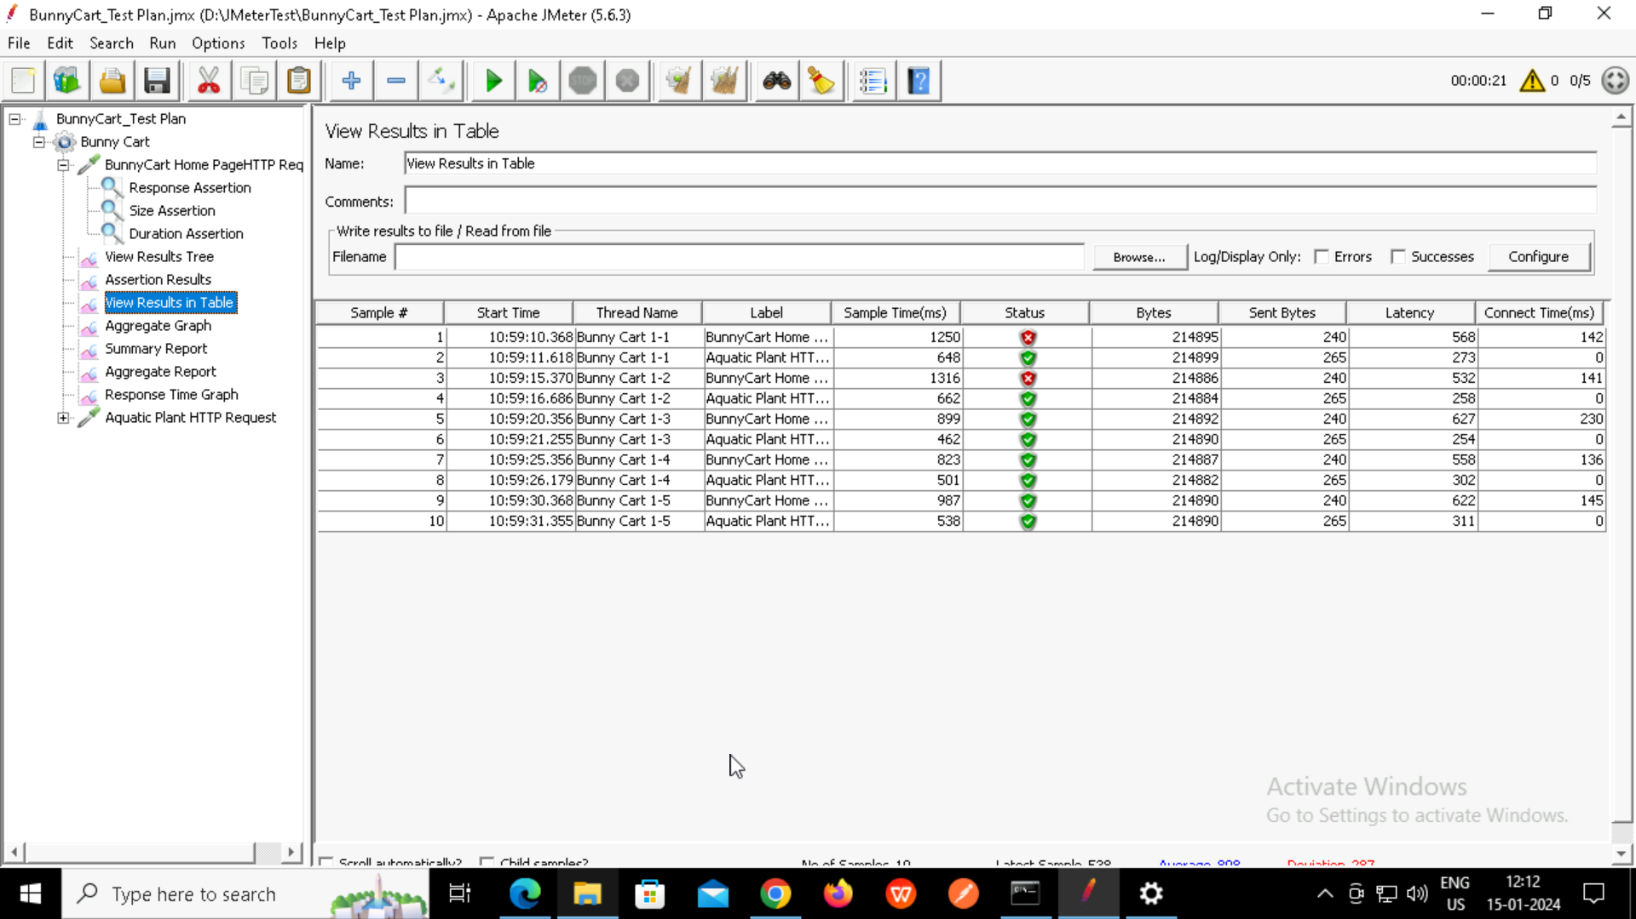

**Aggregate Graph:**

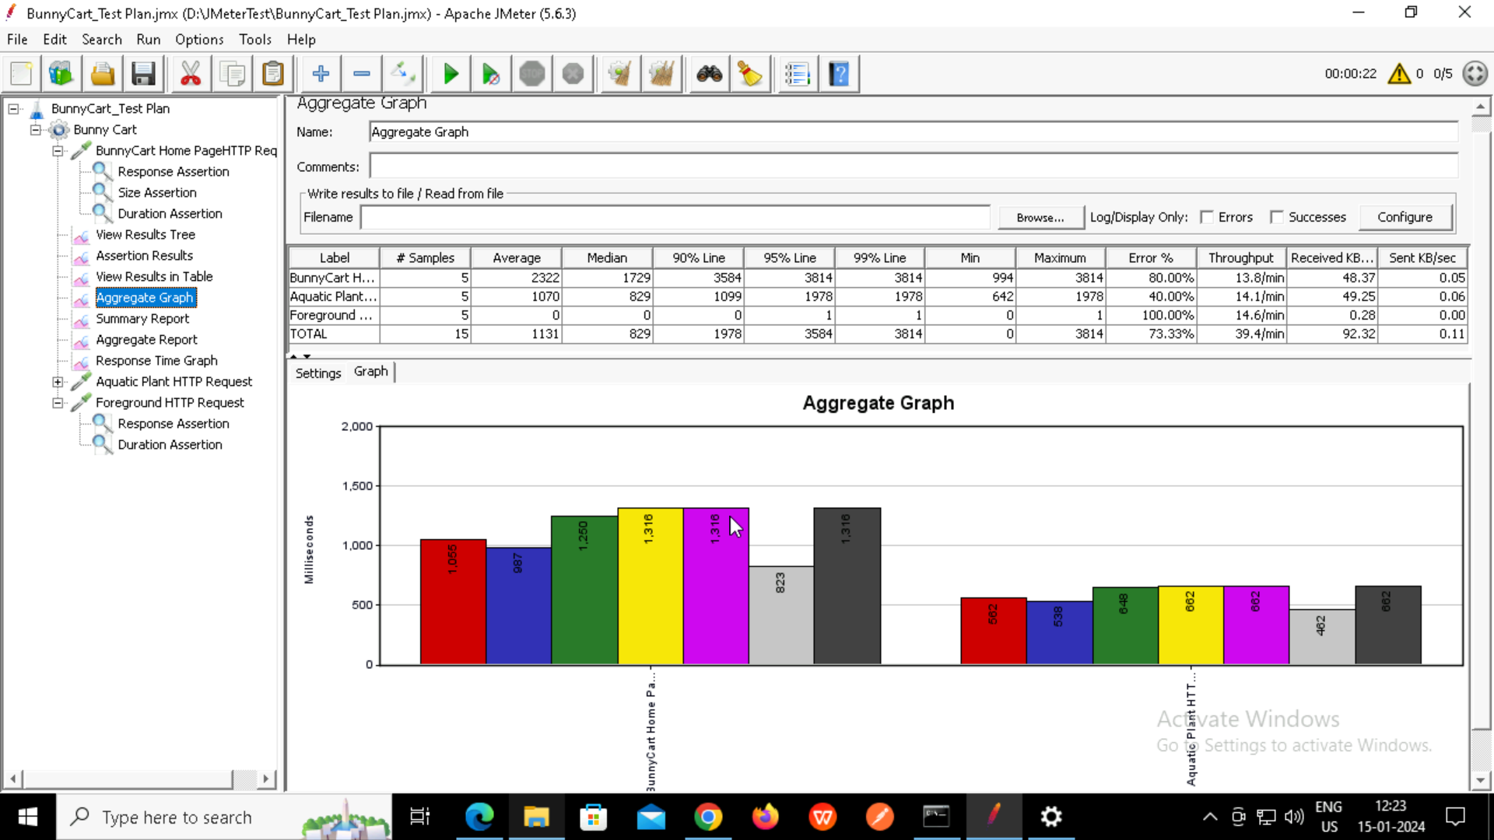

**Summary Report:**

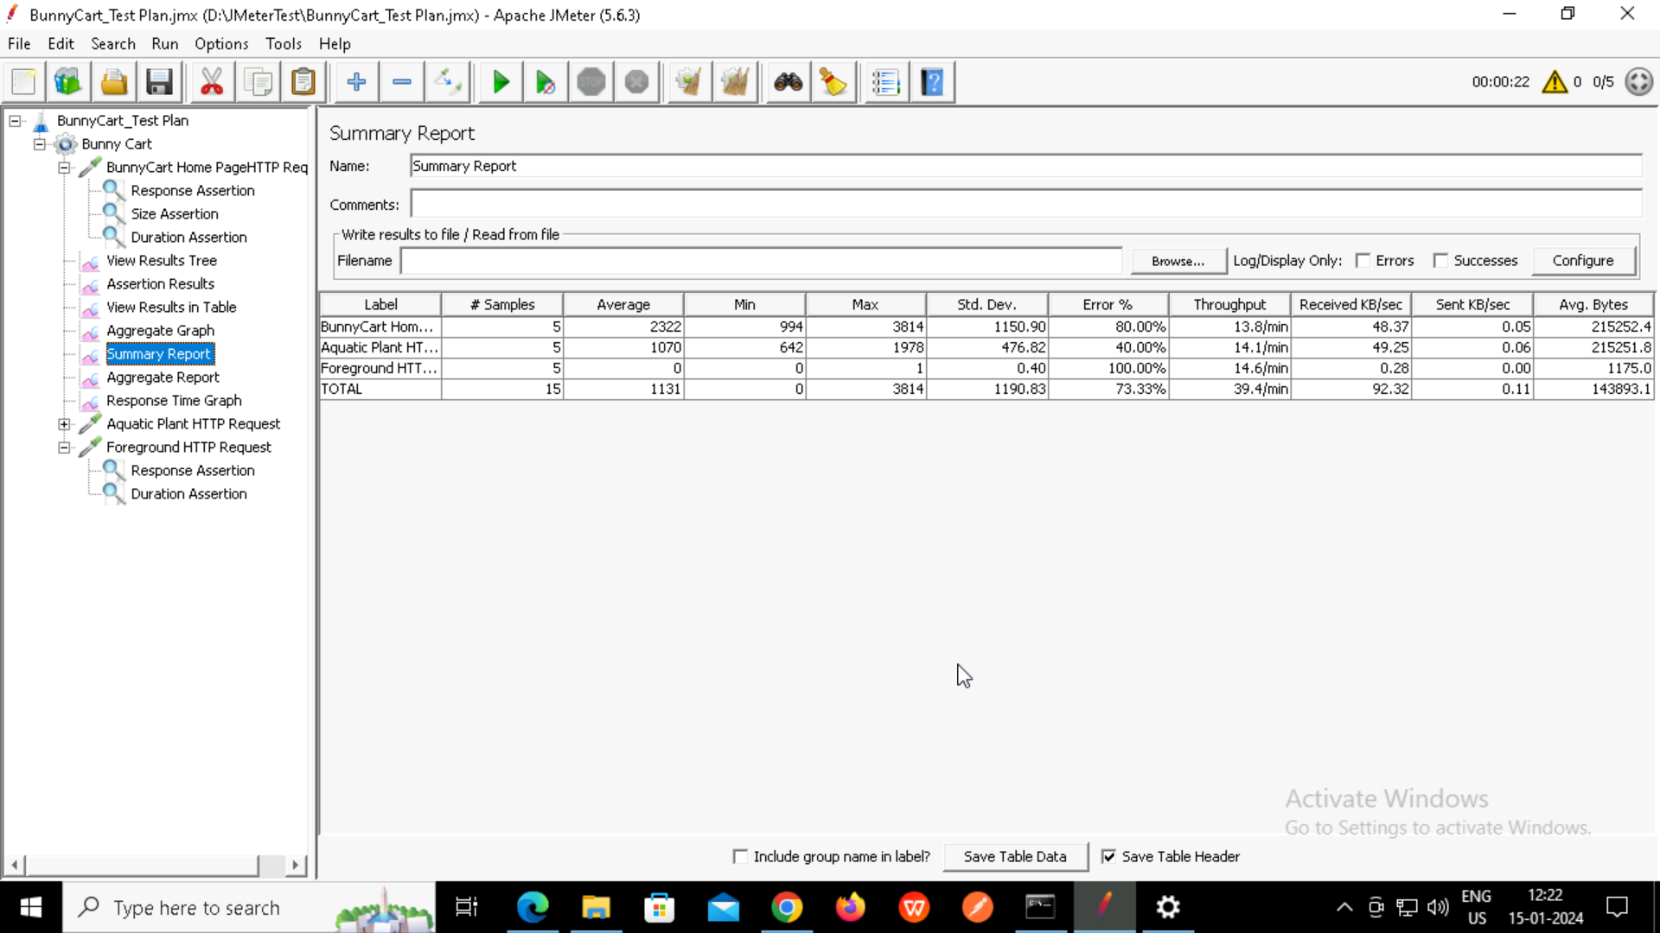

**Aggregate Report:**

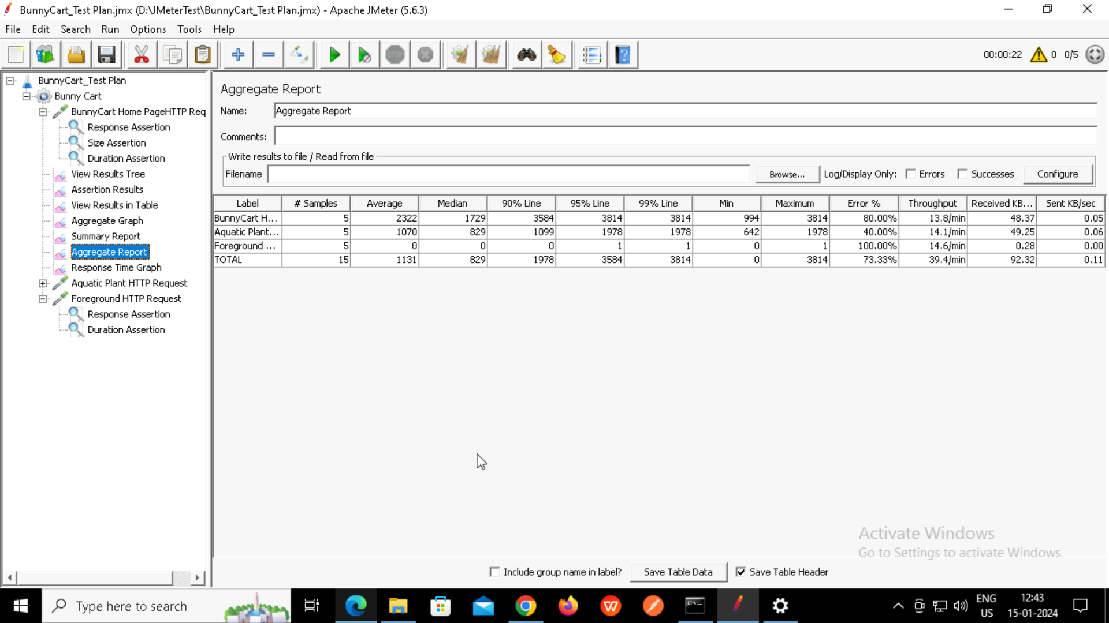

**Response Time Graph:**

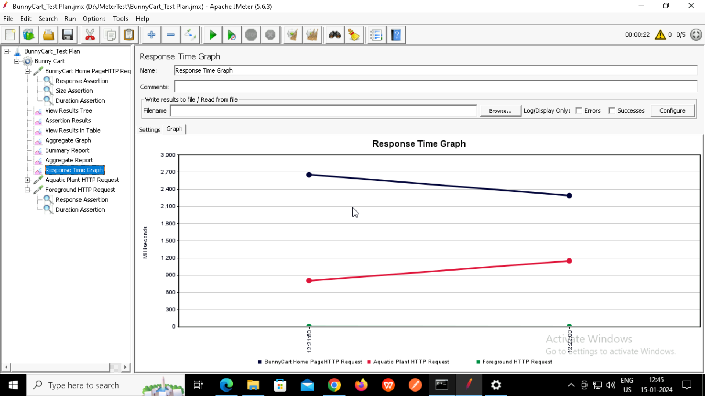

**Navigating the Home Page to Aquatic Plant Page**

Aquatic HTTP Request:

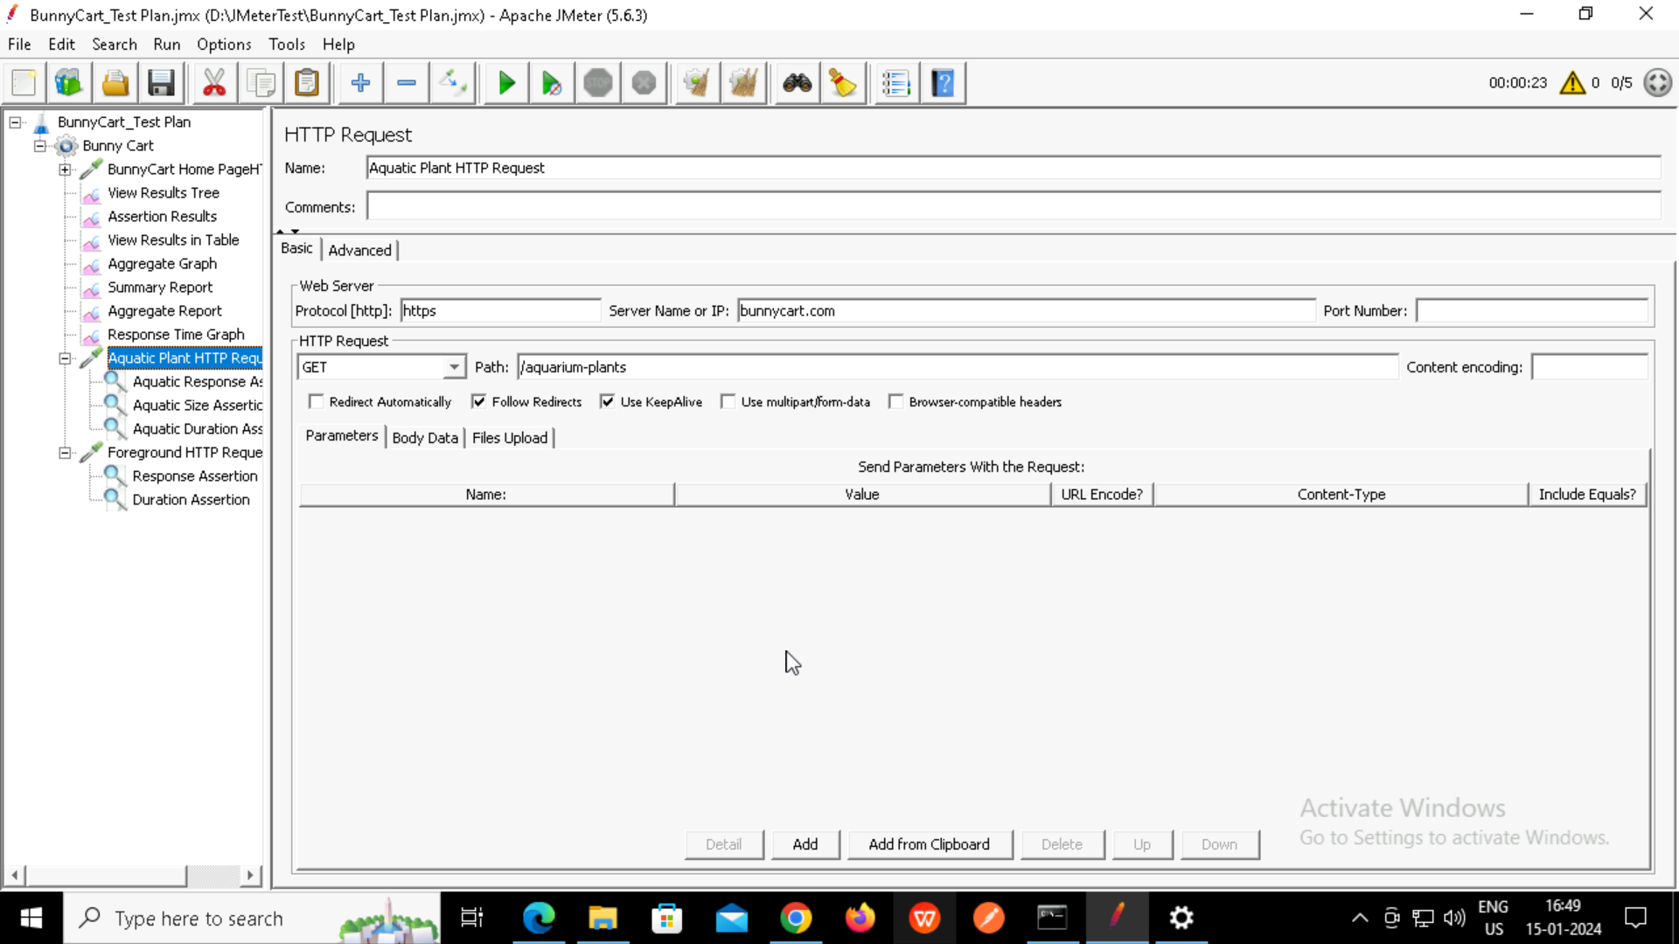

**Response Assertion:**

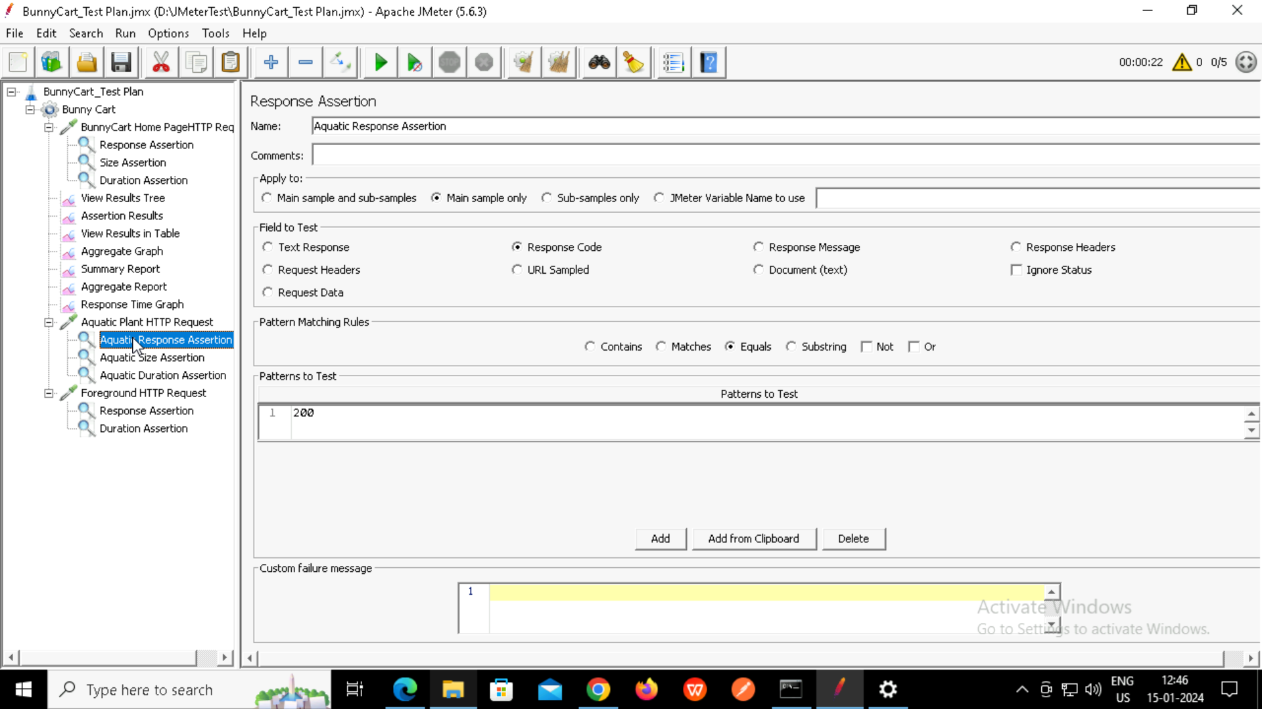

**Size Assertion:**

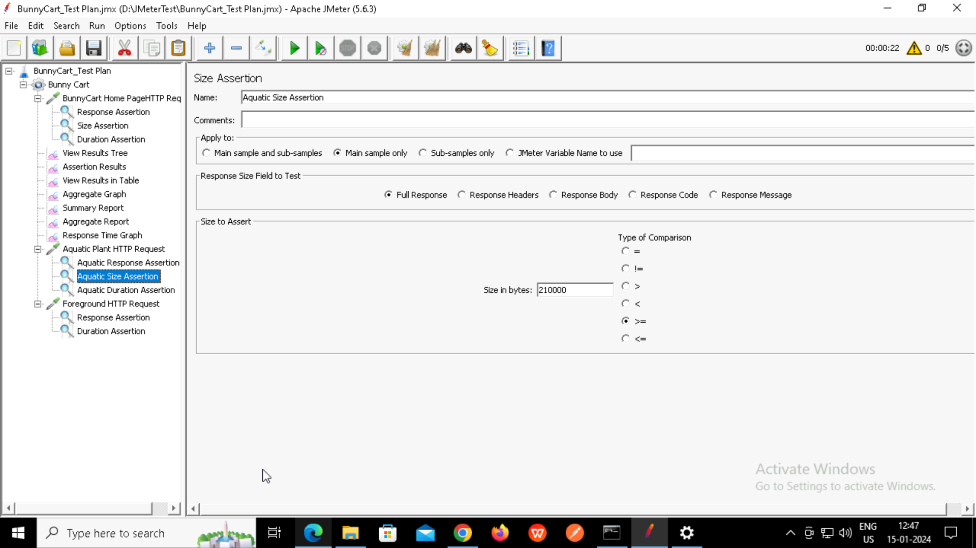

**Duration Assertion:**

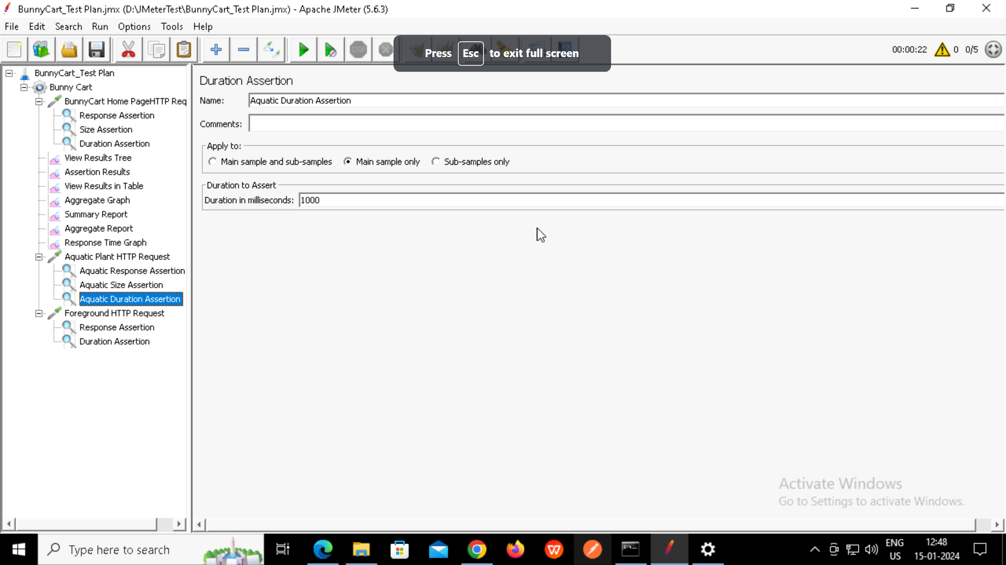

**ForeGround HTTP Request:**

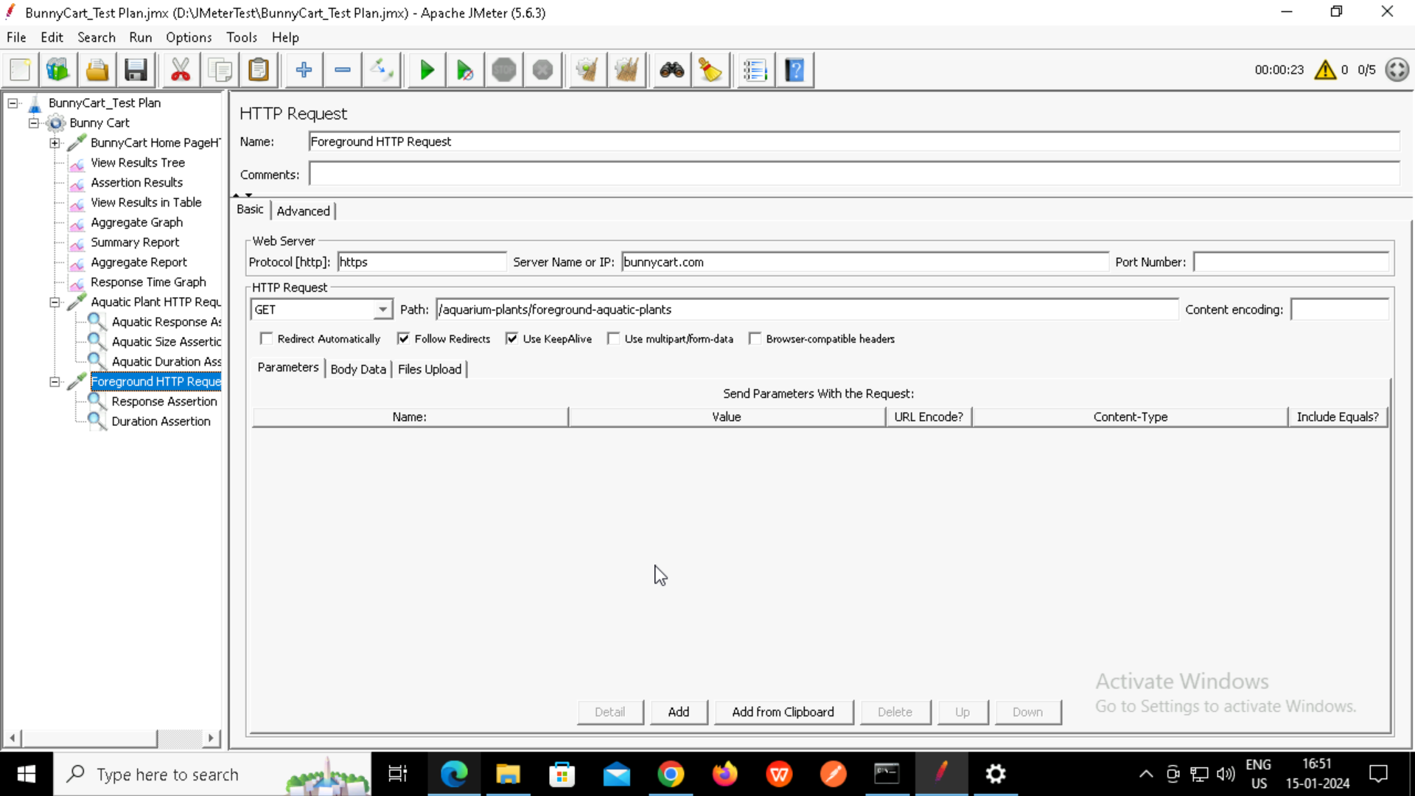

**Response Assertion:**

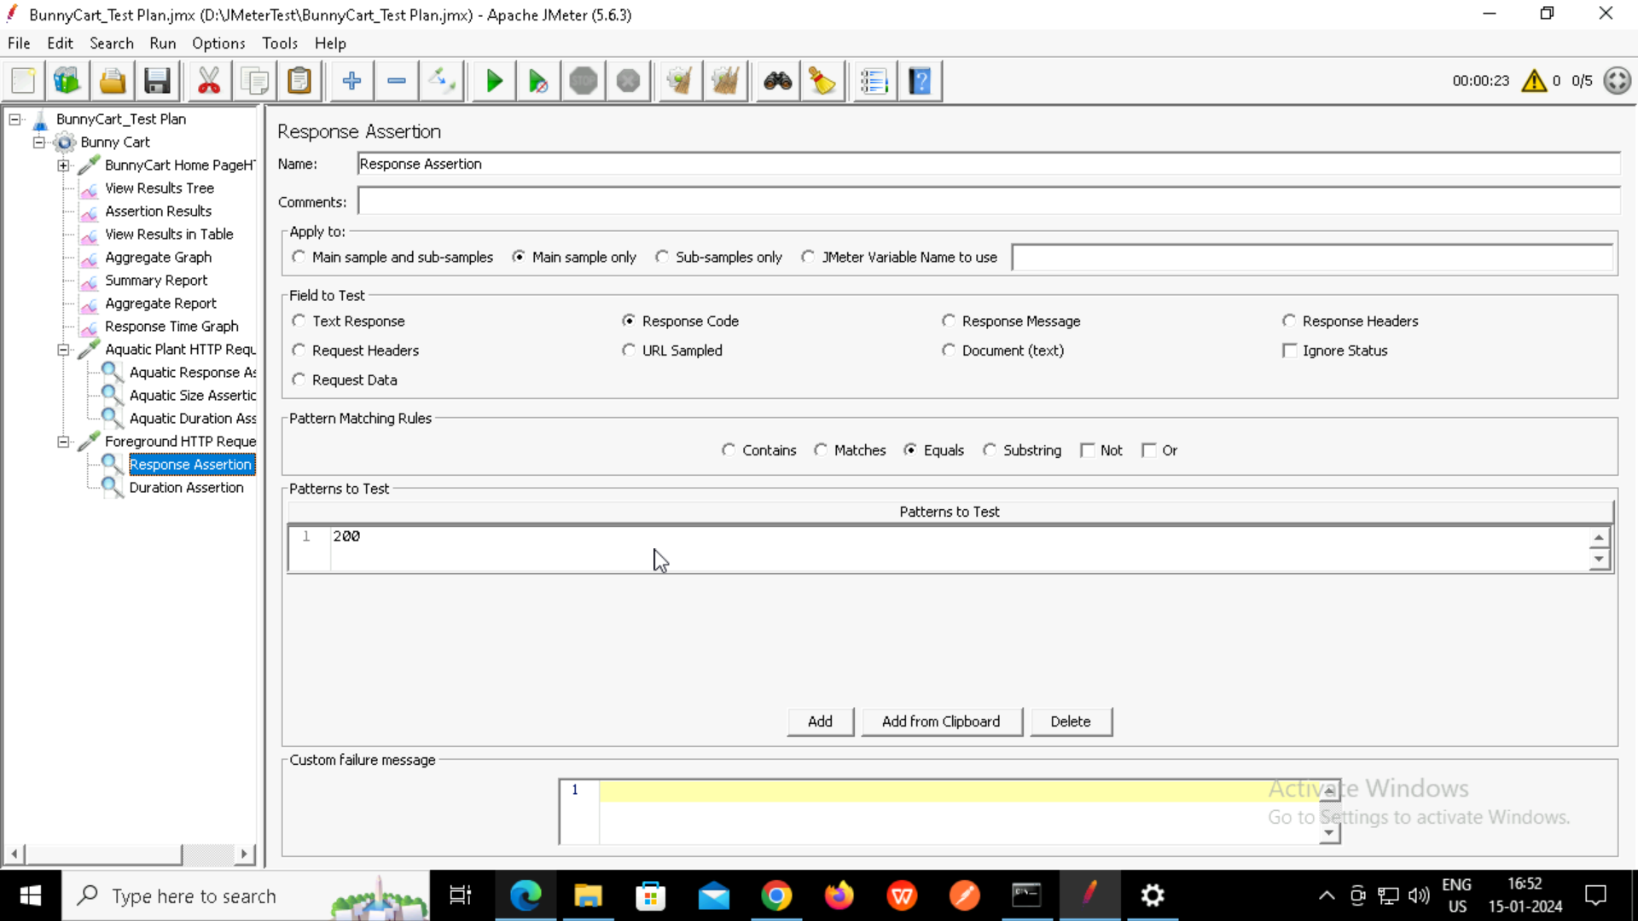

**Duration Assertion:**

